A. Qualitative analysis: Flame tests, test for cations and ammonia
- A student has three different samples of chemicals. They know that one contains lithium, one contains potassium and one contains calcium. Describe the test she could do to determine which chemical contains which metal. (6)

- The student has another sample that they know contains copper, however when they carry out the flame test they get a yellow colour rather than the expected green. Explain why this happens. (2)

- In a further experiment two solutions contain aluminium and calcium ions. They are tested with sodium hydroxide solution. Describe the similarities and differences in the results they would get. (3)

- The following reaction was carried out in a laboratory:
Ca(OH)₂ + 2NH₄Cl → 2NH₃ + CaCl₂ + 2H₂O
Describe how the scientist could test the gas produced to prove its identity. (3)
B. Qualitative analysis: Tests for carbonates, halides and sulfates
- A chemist believed that a sample of water contained iodide and sulfate ions. When it was tested with silver nitrate a cream precipitate was produced; when tested with barium chloride a white precipitate was produced. What ions were present in the water? Write balanced symbol equations for the positive results, include state symbols. (6)

- The labels have fallen off three bottles; two contained a sodium salt, the other a copper salt. A scientist wanted to test the chemicals to identify which was which. The copper salt and one of sodium salts contained the same anion.
  - What test should the scientist use to distinguish between the copper and sodium ions? State the expected results. (3)

  - To distinguish between the sodium salts the scientist added dilute acid; substance B produced a gas which turned limewater milky. She then tested the salts using dilute hydrochloric acid and barium chloride solution, substance A produced a white precipitate. State the identities of substances A and B. Explain your answer. (4)

- Describe how sodium hydroxide solution can be used to show that ammonium ions are present. (3)

- Explain how a scientist could differentiate between: sodium sulfate, potassium sulfate, potassium iodide and sodium iodide. (6)

- Look at the following results obtained by a student when testing for halide ions. Describe the test carried out and identify the halide ions present. (4)
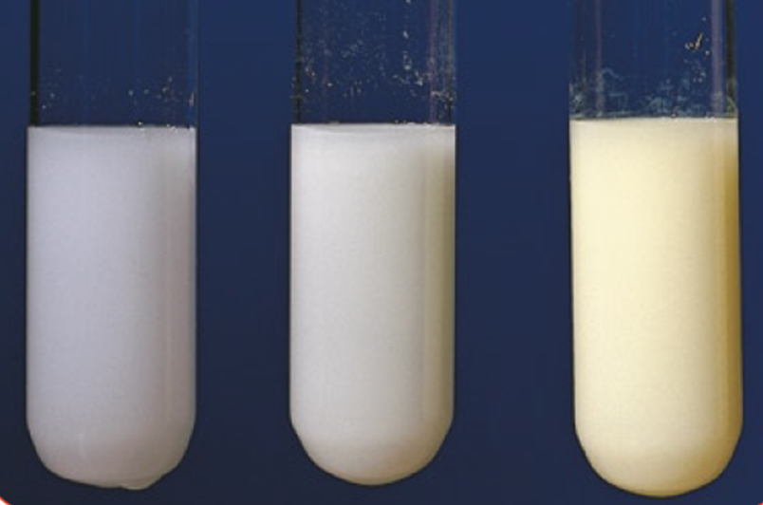
A: White  precipitate | B: Cream precipitate | C: Yellow precipitate

C. Qualitative analysis: Flame photometer
- Elements and compounds can be identified using instrumental methods rather than chemical tests. Describe the potential benefits of instrumental methods of analysis. (3)

- A scientist used a flame photometer to measure the concentration of sodium ions in a solution in parts per million (ppm). As part of the process she created a calibration curve using known concentrations of sodium ions.
She then tested an unknown sample in the flame photometer and obtained a relative flame photometer signal of 35%.
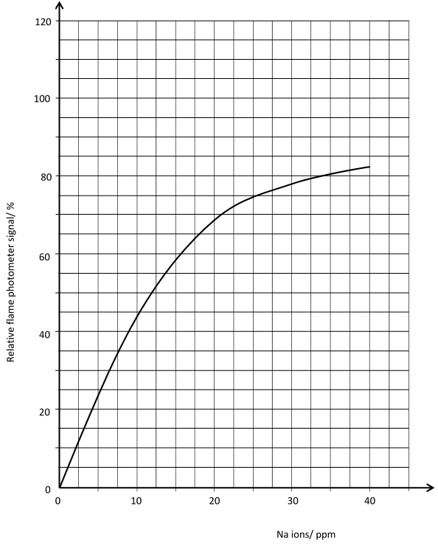

- Use the graph to determine the sodium ion concentration in the unknown sample.

- What relative flame photometer signal would you expect to get with a sodium ion sample of 25 ppm?

C. Alkanes and alkenes
- Give the name and formulae for the first two alkanes in the homologous series. (2)

- The cracking of hydrocarbons can make alkanes and one other type of chemical. Name this chemical and describe a chemical test that could be used to identify between this chemical and the alkane. Give the positive test result as part of your answer. (3)

- Alkenes are hydrocarbons with a double carbon – carbon bond. Give the general formula of the alkenes and explain why they are called unsaturated. (2)

- Butene is an alkene that contains four carbon atoms. Write out its formula and draw its structural formula. (2)

- Ethene reacts with bromine water. What type of reaction is this? Include an equation showing the structures of the reactants and products. (3)

- Complete combustion of alkanes and alkenes produces carbon dioxide and water. What type of reaction is this? Include a balanced symbol equation for the complete combustion of propane. (3)
D. Polymers: Addition polymerisation and condensation polymerisation (HT)

- Explain what happens during addition polymerisation. (3)

- Below is the monomer vinyl chloride. Draw the structural formula for the addition polymer it will make and show the repeating unit. (4)

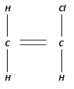

- (HT) Explain what happens during condensation polymerization. (3)

- (HT) Propane diol polymerises with butanedioc acid to produce a polyester. Explain, using a symbol equation, how these monomers produce a condensation polymer (polyester). (3)

Propane diol HO – CH₂ – CH₂ – CH₂ – OH

Butanedioc acid HOOC – CH₂ - CH₂ –COOH

- Describe problems associated with polymers. (4)

E. Polymers: DNA and other naturally occurring polymers
- DNA is a polymer. Explain why. (2)

- Name the monomers found in the naturally occurring polymers starch and protein. (2)
F. Reactions of alcohols and carboxylic acids
- A student carried out an experiment to investigate the temperature rise produced in a known mass of water by combusting ethanol and pentanol.
  - Describe and explain the results the student would expect to see. Identify two control variables for the experiment. (4)

  - Explain why the results may be lower than expected. (3)

- Ethanol C₂H₅OH is made during fermentation. Draw the structural formula of ethanol, describe the conditions needed for fermentation and explain why one of the conditions is the absence of oxygen. (6)

- Draw the structure of propanoic acid and indicate the functional group. (3)

- Describe what you would see if calcium carbonate was added to propanoic acid and compare this to the reaction of calcium carbonate with nitric acid. Explain the difference in the reactions. (6)

G. Nanoparticles: Sizes of particles and their properties, uses of nanoparticles
- How many nanometres make up 1 millimetre? (1)

- What is a nanoparticle? (1)

- Explain why nanoparticles would make very efficient catalysts. (2)

- Describe one social and one economic benefit of nanoscience. (2)

- Calculate the surface area to volume ratio of the following cube. (3)
3cm

